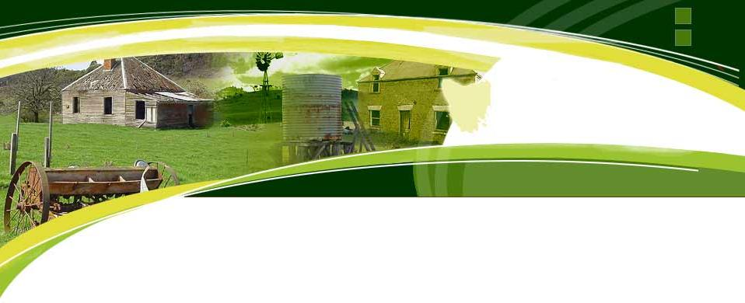

COMMUNITY SMALL GRANTS

APPLICATION FORM

Round Two - 2023

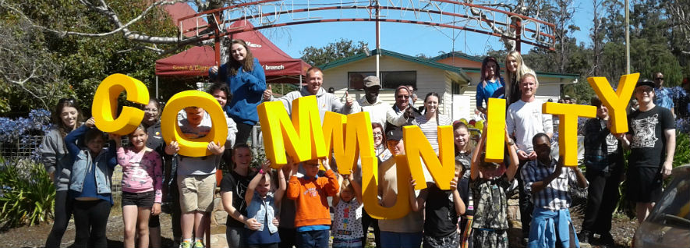
This application form is to be completed by eligible groups wishing to obtain funds from the Southern Midlands Council Community Small Grants program for 2023. Applications will be open for acceptance from 8.30 a.m. Wednesday 2 October 2023 to 4.00 p.m. Monday 13 November 2023 inclusive. Unfortunately, late, or incomplete applications will not be able to be accepted.

SECTION 1 – GENERAL INFORMATION
Organisation undertaking the project
Name:
Address:
Postal Address:
Email:

* If your organisation is not incorporated you will need to appoint an incorporated group to handle any funds. This incorporated group or body is known as an “auspicing organisation” and is required to submit a letter on their letterhead indicating support for the project and willingness to auspice any funds received. Whilst the auspicing body is a legal entity the auspiced organisation must be able to demonstrate its financial viability to deliver the project, to enable the assessment panel to understand the ability of the Grantee to deliver the grant outcomes in weighing up the appropriate use of public funds.

*Details for correspondence of auspice* organisation managing the project (if applicable)
Name of Auspicing Organisation:
Postal Address:
Phone:
Email:
Name of Authorised Person:
Signature:

Please attach supporting evidence of the financial viability of the applicant (not the auspicing body) to deliver the project outcomes
Supporting evidence:

Project Contact Person
Name / Position:
Email:
Mobile:

Secondary Contact Person
Name / Position:
Email:
Mobile:

Club / Organisation Details (if under the auspice of another body please put their details here)
Incorporation No:
Are you registered for GST? | ☐ Yes ☐ No  (if registered for GST, the grant amount will be GST inclusive)
Do you have an ABN? | ☐ Yes ABN No:  ☐ No  (if you do not have an ABN, complete a ‘Statement of Supplier Form’ which can be found on the SMC website)
Do you have Public Liability Insurance? | ☐ Yes (if yes, attach a copy of your Certificate of Currency)  ☐ No

GRANT AMOUNT REQUESTED | $ (GST inclusive)

Council may not be able to fund the full amount requested .Please advise the minimum amount that
would still allow the project to continue

$ .

Applicants are reminded that:

- ALL QUESTIONS MUST BE COMPLETED. Incomplete applications will be returned and not considered for assistance until complete.
- ALL items and attachments listed in the checklist must be provided at the time of application.
- Applications MUST be completed on the form provided and not altered in any way.

If you anticipate having difficulty with any of these requirements please contact Council’s Deputy General Manager, Andrew Benson on 6254 5050 or via email abenson@southernmidlands.tas.gov.au prior to submitting your application.

SECTION 2 – PROJECT DETAILS

Project Type: | ☐ Community ☐ Building ☐ Minor Capital Works  ☐ Safety/Access ☐ Equipment
Project Title:

Project Location/Address:
(Facility/Reserve/Venue)
Project Date:
(if ongoing please indicate commencement date)

Please attach a 1 page summary of your group/organisation mission, goals and aims?
(This should be on your organisations official letterhead – where possible)

Summary attached ☐

What is the purpose of this project?
briefly tell us what you hope to achieve from your project and why you think this is the way to achieve it

Will your project require co-ordination with other groups in the community?
If yes, who are they and how will they be involved?

What community support do you have for your project?
Please attach any letters of support if applicable.

SECTION 3 – PROJECT TIMELINES / COSTS

Approximate Start Date | Completion Date

PROJECT COSTS
Item/Quote | Description/Quantity | Suggested Supplier/Provider | Total Cost
 |  |  | $
 |  |  | $
 |  |  | $
 |  |  | $
 |  |  | $
TOTAL PROJECT COSTS  (** Must equal / exceed grant sought ) |  |  | $
*Please attach written quotations with your application – internet quotations are acceptable.

PROJECT INCOME
Funding Source  Confirmed or Anticipated monies that you will put into the Project | Total
Direct Club / Group Contribution (enclose Bank Statement) | $
Sponsorship / Fundraising | $
Member contributions or cover / admission charges | $
Other governing body / external grant contributions  (please specify & attach evidence) | $
In-kind Contributions (eg Volunteer labour – allow $25 per hour ) | $
Other Income | $
 | $
 | $
GRANT REQUESTED (max. $3000) | $
TOTAL PROJECT INCOME  (Must equal or exceed Project Costs) | $

Does your group/organisation have any debt/monies owing to Council? | ☐ Yes If yes, a debt of $  ☐ No
If yes, please provide a brief description of the debt purpose:

Has your organisation previously received assistance from Southern Midlands Council? | ☐ Yes If yes, a grant of $  ☐ No
Financial Year(s) received:

Please provide a brief description of the previous grant(s):

If your organisation was a recipient of a grant in the 2022 SMC Community Small Grants Program was this acquitted in accordance with the grant requirements?

Acquitted in accordance with grant requirements? | ☐ Yes ☐ No
If NO do you have a letter from Council authorising a variation of that agreement? | ☐ Yes ☐ No

Please Note If your organisation was a recipient of a Grant in the 2022 SMC Community Small Grants Program and this has not been acquitted in accordance with the Grant requirements, it makes an application for this 2023 Grant round invalid.

Was your organisation a recipient of a grant in the 2023 SMC Community Small Grants Program Round One (September 2023)? | ☐ Yes ☐ No

SECTION 4 – APPLICANT DECLARATION

I affirm that the details in this application and attachments are true and correct to the best of my knowledge and that the application form has been submitted with the full knowledge and agreement of the applicant organisation. I acknowledge that I have read and understood the SMC Community Small Grant Program Round Two - 2023 Guidelines on behalf of the applicant organisation and that any funds provided by the Southern Midlands Council will be expended in the following manner:

- In accordance with the Community Small Grants Program Guidelines Round Two - 2023
- To the benefit of the Southern Midlands Community
- As outlined in this application

I understand that Council, its servants, agents and employees shall not be responsible at any time for any liability incurred or entered into by the applicant as a result of or arising out of the Applicant’s responsibilities under this agreement.

The Applicant shall release and indemnify the Council, it’s servants, agents and employees against any claim, demand, liability, cost, expenses, actions arising out of or in any way connected with the activities of the Applicant, or the Applicants agent in consequence of this agreement except where the claim, demand, liability, cost or action are caused by the Council or it’s servants or agents.

Signed by:

Project Manager (PRINT NAME)
Position:
For and on behalf of (Club/Group)
Date:
Signature:

President / Chairperson (PRINT NAME)
Position:
For and on behalf of (Club/Group)
Date:
Signature:

NOTE:

The Project Manager must be contactable for 7 days after the closing date for clarification of the project if required.

SECTION 5 – APPLICATION CHECKLIST

APPLICATIONS WILL NOT BE ACCEPTED UNTIL ALL RELEVANT INFORMATION HAS BEEN RECEIVED

Please tick boxes to ensure that you have included all required information.

General
☐ All questions have been completed and the application form signed
☐ Feedback Sheet has been completed and attached
☐ You have retained a copy of your application for your records

Attachments
☐ 1 page summary of your organisations mission, goals and aims
☐ Last year’s financial statements & latest Bank account statement
☐ Evidence of public liability cover held (Certificate of Currency)
☐ Project Quotes
☐ Other governing body / external grant contributions (if applicable)
☐ Supporting documentation of your (Grantees) financial viability if you are using an Auspicing body
☐ Any letters of support you wish to include

APPLICATIONS CLOSE:

4.00 p.m. on Monday, 13 November 2023

Applications can be sent to:

Tim Kirkwood - General Manager
Southern Midlands Council
PO Box 21, OATLANDS TAS 7120

or E-mailed to

mail@southernmidlands.tas.gov.au

Enquiries to:

Andrew Benson
Deputy General Manager
Southern Midlands Council

Tel: 036254 5050
Mob: 0429 852 730
Email: abenson@southernmidlands.tas.gov.au
Website: www.southernmidlands.tas.gov.au

FEEDBACK SHEET
COMMUNITY SMALL GRANTS Round Two 2023

Please assist us to improve the Southern Midlands Council Community Small Grants Program by completing this feedback sheet and returning it with your application.

How did you hear about the Community Small Grants Program?
☐ Word of Mouth ☐ Mailing List ☐ SMC Website
☐ SMC Newsletter ☐ Word of Mouth ☐ Ad in Mercury
☐ Facebook ☐ Other

Was the advertising adequate for your group/organisation? ☐ Yes ☐ No

If NO, how do you suggest the promotion could be improved?

Was there sufficient time to prepare your application before the closing date? ☐ Yes ☐ No

If NO, what was the barrier preventing a timely application being submitted?

Is the closing date for applications appropriate for your organisation’s needs? ☐ Yes ☐ No

If NO, what is your preferred closing date and why?

Are the forms clear and easy to use? ☐ Yes ☐ No

If NO, please give details on how they can be improved?

Are the grant allocation and eligibility criteria clear and easy to understand? ☐ Yes ☐ No

If NO, please give details?

Do you have any other comments about the SMC Community Small Grants Program?

~Thank you for taking the time to complete this feedback sheet~

